DERBY DAY
User Manual
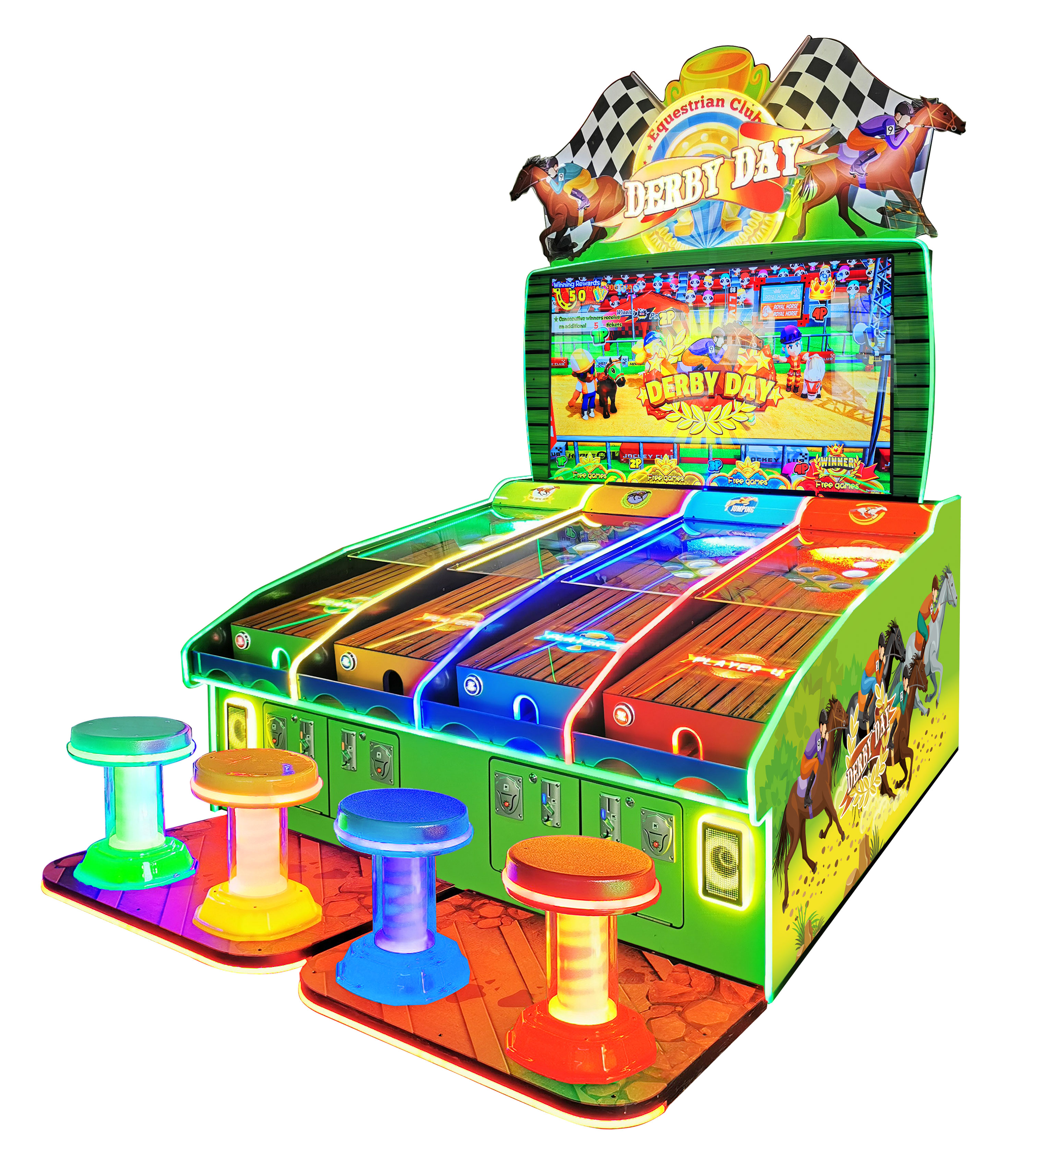



Please read this User Manual carefully before you installing this product.

CONTENT

Ⅰ. BRIEF INTRODUCTION OF GAME 1
Ⅱ．DIMENSION AND TECHNICAL PARAMETER 2
Ⅲ. PARTS LIST 3
Ⅳ．THE STRUCTURE OF MACHINE 4
Ⅴ、INSTALLATION AND MOVING 5
Ⅵ. METHOD OF POWER CONNECTION 6
Ⅶ、POWER BOX DESCRIPTION 6
Ⅷ．USE AND MAINTENANCE GUIDE 7
Ⅸ. BACKSTAGE SETTING 8
Ⅹ. IO CONNECTING TABLE 12

Ⅰ. BRIEF INTRODUCTION OF GAME
Features
1. Redemption machines.
2. The game is new, exciting and entertaining.
3. The appearance is elegant, colorful and delicate.
4. Used with large-scale integrated circuits and built-in programs. The functionality is stable and reliable.
5. Used with high quality ticket dispenser.
6. Meet the general type of tickets.
7. Use high quality coin selector, the diameter of coins can be adjusted from 20mm to 28mm,which is accurate and stable.
8. Game programming and revenue ratio are easily to adjust.

How To Play：
- Insert coin, press the button to start the game.
- Roll the ball into the hole, and you can get scores, and the horse will go forward according to the scores.
- The one who reaches the finish first will win.

Ⅱ．DIMENSION AND TECHNICAL PARAMETER
- Voltage: AC220V±5% 50Hz or AC 110V±5% (or make the reference with the mark)；
- Power：1000 W；
- Dimension：W2078*D2562*H2934（mm）;
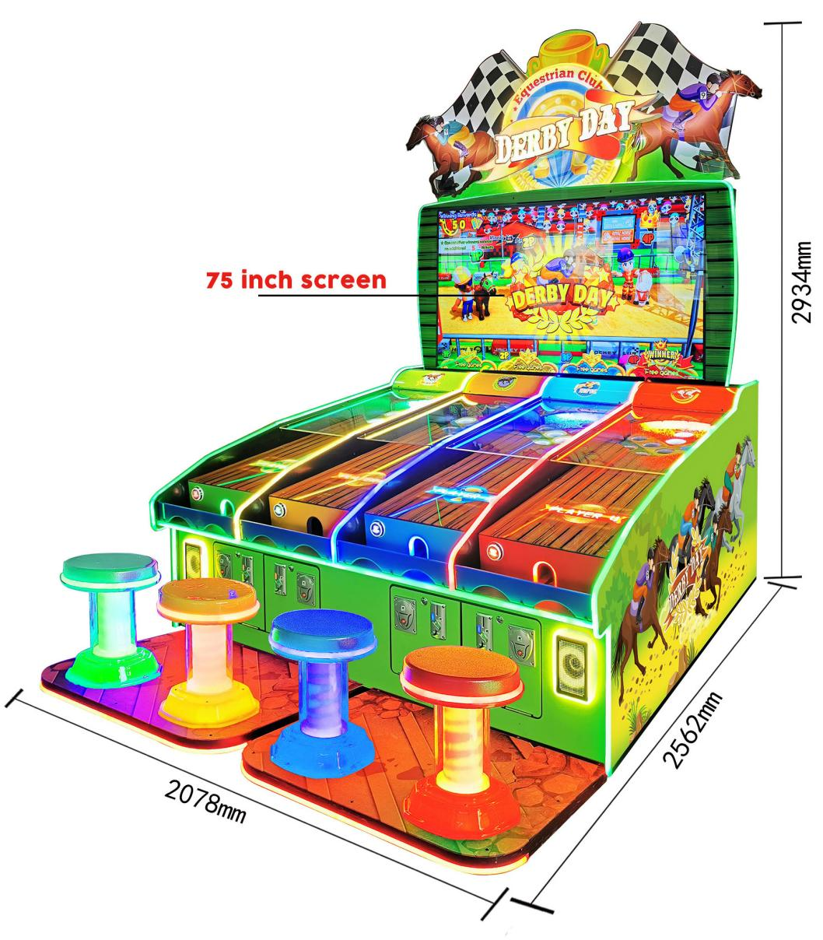

- Weight：About 400kg;
- THE TEMPERATURE（INDOOR） ：-10~+40℃
HUMIDITY：≤90%;
PRESSURE：86Pa~106Pa.

Ⅲ. PARTS LIST
In order to use the machine normally , Please check it carefully after you open the package box to see whether it have the following items:
- A main machine;
- A set of repair parts, list as the below
No. | Parts name | Specification | QTY |  | Picture | Remark
1 | Power line | 1．8m | 1 | PC | 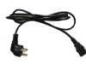
2 | Fuse Tube | 5XΦ20mm | 2 | PC |  | 10A
3 | User Manual |  | 1 | PC
4 | Key of Coin box | AH78 | 2 | PC
5 | Key of maintenance door | AH57 | 3 | PC |  | Front door and back door

Ⅳ．THE STRUCTURE OF MACHINE
Top Flash

Screen

Loudspeaker
Start Button

Ticket out
Seat

Insert
coins

Ⅴ、INSTALLATION AND MOVING
1．This machine only can be use in the indoor, outdoor is prohibited；
It will affect the function if you use it outdoor.
2．Range for placement：
The machine should be placed as the following range, enough space can make it cool down better.

4、When moving it , you must pay attention to the following：
（1）You must turn off the power and pull the power connection out before moving.
（2）If the caster can not move, please change the castors.
（3）Any moving, turning and transport artificial random could damage the device and destroyed the mechanical properties .
（4）Confirmed the process of moving , flipping and transportation meet the manufacturers requirements.

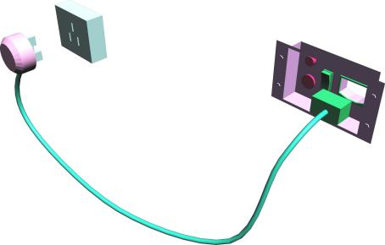
Ⅵ. METHOD OF POWER CONNECTION
Look-out：
Power cord can not be pressed by heavy objects, which would easily cause short circuit and may lead to serious fires.
  - When you pull the power cord out form the socket, you should seize the plug prefer grasp the wire.
  - Can not pull the plug directly with wet hands.
  - Can not force stretched and twisted the power cord, and the power cord can not be expose or near the object which is in high temperatures.
  - The power cord can not be kicked or contact easily.
  - Must use the correct voltage and fuse (See the specification)

Ⅶ、POWER BOX DESCRIPTION
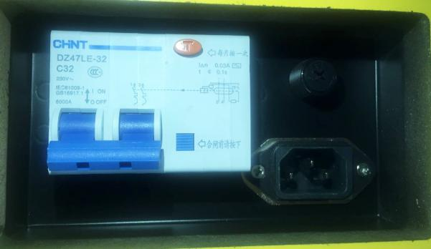
Power switch

Power socket

This machine uses AC“220V±5% 50HZ（or 110V±5% 60HZ）
- The fuse is in fuse holder，the standard of fuse is “220V 6A diameter 5-20mm(or 110V 12V diameter 5-20mm)
- The power switch is use for turn on/off the connection.
- Ground terminal: connection with the dedicated ground.

Ⅷ．USE AND MAINTENANCE GUIDE
1．Machines for maintenance and repairs, you must turn off the power .
In order to avoid short circuit, the persons concerned access to machine internal components before you turn off the power source. If it requires power, shall meet the requirements of operating instructions
2．When you replace a component determines when the appropriate choice of accessories.
Use of incorrect parts can result in fire or electrical short circuit, damage to the Board, and no device
3．Don't arbitrarily split the Royal, Assembly, alter equipment. This can cause fire or an electrical short circuit, mechanical failures, and so on.
4．Confirm the move, flip, transport and so on to meet manufacturers request. Random people-moving, can damage equipment such as flip, transport, destruction of machinery performance.
5．This machine is suitable for indoor use, should not be used outdoors.
Outdoor use will affect the performance of the machine.
6．Not in the following places
★Place where leakage or high humidity
★Close to the places of high temperature objects
★Close to dangerous goods.
★Slippery or unstable place.
★Equipment close to the spark
★Shock serious place
★Dusty environment
7．Do not place any containers that are filled with water on the above. Liquid overflow will cause electrical short circuit damage devices, chemical corrosion machine, will harm the human body falling from a height and destruction of the machine.
8．Do not place objects at the vent being blocked will cause the temperature rise, affect the functioning of machines or even damage the device.

Ⅸ. BACKSTAGE SETTING
Main Menu
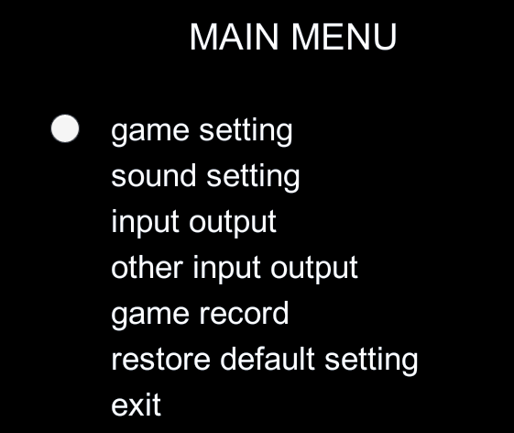

- Game Setting：Enter game setting menu
- Sound Setting：Enter sound setting menu
- Input output: Input and output for general function
- Other input output: Input and output for light strip
- Game Record：To enter the record menu
- Restore Default Setting：Restore Default Setting
- Exit：Back to game

Game Setting
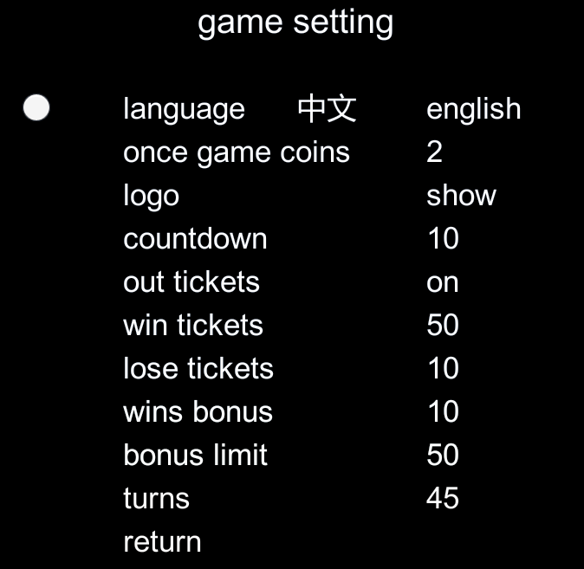
- Language：To set the language
- Once game coins：To set the coins qty per game
- LOGO: To set if the LOGO shown in the screen
- Countdown：Countdown for game start
- Out Ticket：To set ticket out or not
- Win Ticket：To set tickets qty for winner
- Lose Ticket：To set tickets qty for other player
- Wins Bonus：To set bonus tickets qty for the player who wins continuously
- Bonus Limit: To set the limit of bonus tickets
- Turns: To set the paces for a horse to finish the game.
- Return：Back to last menu

Sound Setting
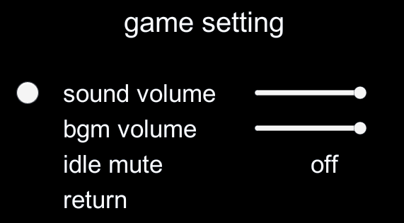
- Sound Volume：To set the volume of game effect music
- Bgm Volume：To set the volume of background music
- Idle Mute：Mute mode or not
- Return：Back to last menu
Player Input Output
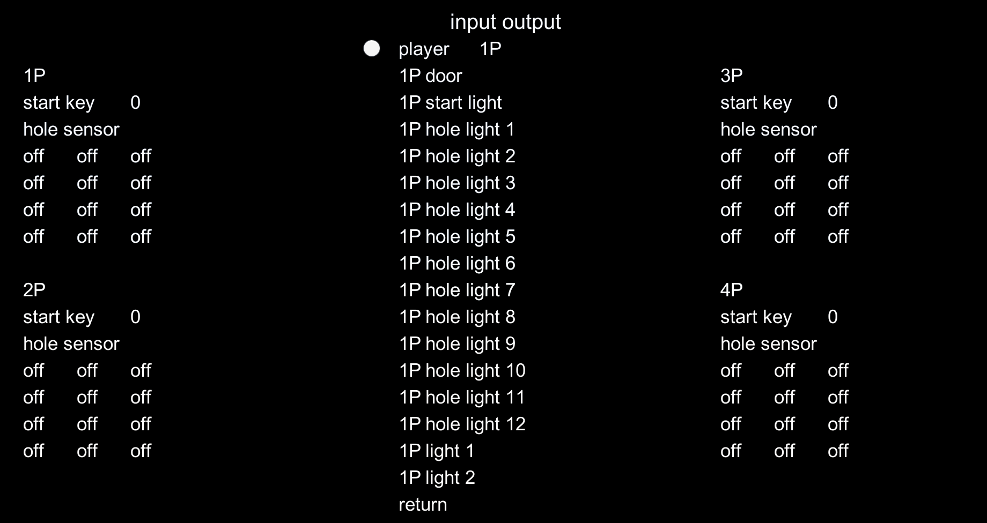

- Player 1P: Choose 1P, 2P, 3P and 4P to check the corresponding output.
- Start Key: To test start button
- Hole sensor: To test sensors of holes
- Door: To test sensor of gate
- Start light: To test light of start button
- Hole light: To test light of hole
- Light: To test led strip

Other input output: To test LED
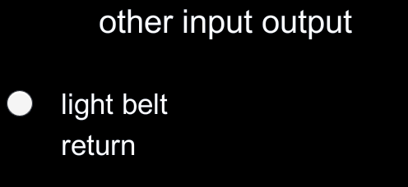

Game Record: To record total coins and tickets
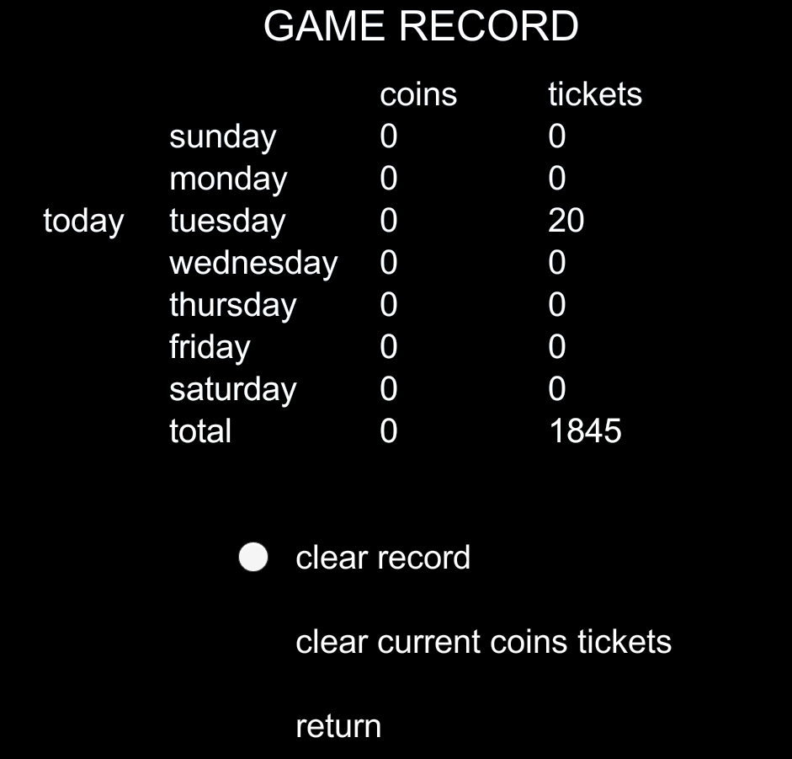

Ⅹ. IO CONNECTING TABLE
Port  编号 | Mark | Function | Terminal | Description | Port  编号
J1 | +12V | Main Power Input | VH |  | Main Power Input
J1 | GND | Main Power Input | VH |  | Main Power Input
J2 | 5V | COM | DB9
J2 | TX3 | COM | DB9
J2 | RX3 | COM | DB9
J2 | GND | COM | DB9
J3 | T1 | COM | VH |  | Connect PC
J3 | R1 | COM | VH |  | Connect PC
J3 | GND | COM | VH |  | Connect PC
J4 | 3.3V | 3.3V Power Supply | VH
J4 | 3.3V | 3.3V Power Supply | VH
J4 | 3.3V | 3.3V Power Supply | VH
J5 | N1 | Low level input | DC3 |  | 1P Coin selector
J5 | N2 | Low level input | DC3 |  | 1P ticket out feedback
J5 | N3 | Low level input | DC3 |  | 1P start button
J5 | N4 | Low level input | DC3 |  | 2P Coin selector
J5 | N5 | Low level input | DC3 |  | 2P ticket out feedback
J5 | N6 | Low level input | DC3 |  | 2P start button
J5 | N7 | Low level input | DC3 |  | 3P Coin selector
J5 | N8 | Low level input | DC3 |  | 3P ticket out feedback
J5 | N9 | Low level input | DC3 |  | 3P start button
J5 | N10 | Low level input | DC3 |  | 4P Coin selector
J5 | N11 | Low level input | DC3 |  | 4P ticket out feedback
J5 | N12 | Low level input | DC3 |  | 4P start button
J5 | N13 | Low level input | DC3
J5 | N14 | Low level input | DC3
J5 | N15 | Low level input | DC3
J5 | N16 | Low level input | DC3
J5 | N17 | Low level input | DC3
J5 | N18 | Low level input | DC3
J5 | N19 | Low level input | DC3
J5 | N20 | Low level input | DC3 |  | Menu and setting
J5 | N21 | Low level input | DC3 |  | Ticket refund
J5 | N22 | Low level input | DC3 |  | service button 1
J5 | N23 | Low level input | DC3 |  | service button 2
J5 | N24 | Low level input | DC3
J5 | N25 | Low level input | DC3
J5 | N26 | Low level input | DC3
J5 | N27 | Low level input | DC3
J5 | N28 | Low level input | DC3
J5 | +5V | Power output | DC3
J5 | +5V | Power output | DC3
J5 | +5V | Power output | DC3
J5 | +5V | Power output | DC3
J5 | +5V | Power output | DC3
J5 | +5V | Power output | DC3
J5 | GND | Ground | DC3
J5 | GND | Ground | DC3
J5 | GND | Ground | DC3
J5 | GND | Ground | DC3
J5 | GND | Ground | DC3
J5 | GND | Ground | DC3
J6 | +3.3V | Power output | XH
J6 | +3.3V | Power output | XH
J6 | A1 | ADC | XH
J6 | A2 | ADC | XH
J6 | A3 | ADC | XH
J6 | A4 | ADC | XH
J6 | A5 | ADC | XH
J6 | A6 | ADC | XH
J6 | A7 | ADC | XH
J6 | A8 | ADC | XH
J6 | GND | Ground | XH |  | potentiometer Power Supply
J6 | GND | Ground | XH |  | potentiometer Power Supply
J7 | T1 | Signal low power output | DC3 |  | 1P ticket dispenser drive
J7 | T2 | Signal low power output | DC3 |  | Light of 1P start button
J7 | T3 | Signal low power output | DC3 |  | 2P ticket dispenser drive
J7 | T4 | Signal low power output | DC3 |  | Light of 2P start button
J7 | T5 | Signal low power output | DC3 |  | 3P ticket dispenser drive
J7 | T6 | Signal low power output | DC3 |  | Light of 3P start button
J7 | T7 | Signal low power output | DC3 |  | 4P ticket dispenser drive
J7 | T8 | Signal low power output | DC3 |  | Light of 4P start button
J7 | T9 | Signal low power output | DC3 |  | LED strip
J7 | T10 | Signal low power output | DC3 |  | Coin counter
J7 | T11 | Signal low power output | DC3 |  | Ticket counter
J7 | T12 | Signal low power output | DC3
J7 | T13 | Signal low power output | DC3
J7 | T14 | Signal low power output | DC3
J7 | T15 | Signal low power output | DC3
J7 | T16 | Signal low power output | DC3
J7 | +12V | Power output | DC3
J7 | +12V | Power output | DC3
J7 | +12V | Power output | DC3
J7 | +12V | Power output | DC3
J7 | GND | Ground | DC3
J7 | GND | Ground | DC3
J7 | GND | Ground | DC3
J7 | GND | Ground | DC3
J8 | T17 | Signal high power output | VH |  | P1 led strip
J8 | T18 | Signal high power output | VH |  | P1 led strip of seat
J8 | T19 | Signal high power output | VH |  | P1 vibration motor
J8 | T20 | Signal high power output | VH |  | P1 gate motor
J8 | T21 | Signal high power output | VH |  | P2 led strip
J8 | T22 | Signal high power output | VH |  | P2 led strip of seat
J8 | T23 | Signal high power output | VH |  | P2 vibration motor
J8 | T24 | Signal high power output | VH |  | P2 gate motor
J8 | +12V | Power output | VH
J8 | +12V | Power output | VH
J9 | T25 | Signal high power output | VH |  | P3 led strip
J9 | T26 | Signal high power output | VH |  | P3 led strip of seat
J9 | T27 | Signal high power output | VH |  | P3 vibration motor
J9 | T28 | Signal high power output | VH |  | P3 gate motor
J9 | T29 | Signal high power output | VH |  | P4 led strip
J9 | T30 | Signal high power output | VH |  | P4 led strip of seat
J9 | T31 | Signal high power output | VH |  | P4 vibration motor
J9 | T32 | Signal high power output | VH |  | P4 gate motor
J9 | +12V | Power output | VH
J9 | +12V | Power output | VH

