**Instructions: This manual is for reference only**

1) The functions of the fourth-generation crane claw mainboard and the boutique mainboard are common, and the only difference is the voltage adjustment value range;

2) The setting and trial buttons are shared, short press to play, press for 1 second to enter the settings, the game has begun to prohibit entering the settings;

3) In the setting interface for 30 seconds without any operation, it will automatically exit the setting;

4) The adjustment method is not explained. The joystick is adjusted left and right. In the settings, the joystick is used to switch up and down. The joystick can adjust the value range left and right. If the value is relatively large, you can long press the joystick left and right to automatically add and subtract. The grab button enters Submenu or save settings to exit submenu;

5) The unspecified units are calculated in ms (milliseconds), for example: 10 = 0.01 seconds, 100 = 0.1 seconds, 1000 = 1 second;

1. **Definition of Motherboard Interface**
2. 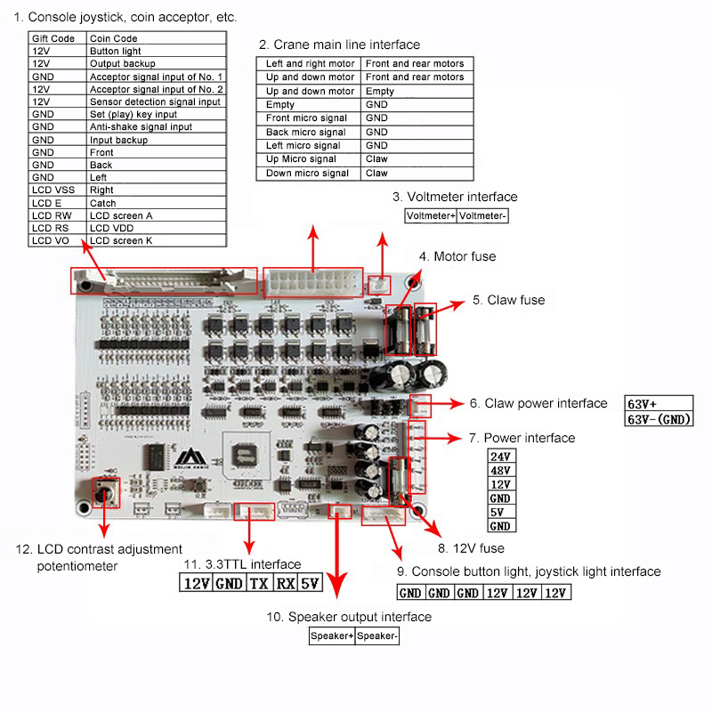**Features**

Setting -> Common, which includes prize mode, probability, countdown, security clip, etc."

"Claw setting -> Common, which includes claw setting, grip maintenance time, etc."

"Gantry setting -> not common, it includes the direction speed of the Gantry, the height of the gift, etc."

"Fixed-point settings -> suitable for game center, the value needs to be high-precision, after adjusting the "Gantry speed", you need to re-calibrate the fixed-point settings, and adjust carefully"

"Throw and grab settings -> This function needs to be combined with the gantry to have specific effects, adjust it carefully"

"Delay Settings -> Common, it is used to protect players from forcibly throwing and grabbing gifts and giving out prizes by mistake"

"Music Settings -> Uncommon, Music Size and Select Music"

"Manufacturer settings -> factory test function, users are not recommended to adjust"

"Account -> Account Check"

"Exit -> Exit Settings"

**1 Game settings**

1) Coins: the joystick can be adjusted left and right to play a few coins, and the joystick can be adjusted back and forth a few times, so that players can play a few games by throwing in a few coins;

2) Game countdown: It is used for the player to automatically grab the gift time after the player times out in the game;

3) Prize mode: used to give prizes in that way in the game;

①No probability: It is not controlled by probability. There is no probability accumulation in this mode. Players use skill to grab gifts;

②Random mode: Randomly win prizes from 1 to the probability of winning;

③Fixed mode: Fixed how many times the game can win prizes;

④Guanxing mode: not controlled by probability, the probability of winning the prize is the weak grip time, the strong grip time is fixed at 3 seconds, the weak grip + strong grip is a winning cycle, and the strong grip time is completed after the grip is completed to the top. There is a chance to win prizes within the time frame;

4) Prize probability: Adjust the value range 1-999 times, how many times the game will win the prize;

5) Grab in the air: Close - the claws will go down to the bottom to grab the object in the game, open - the claws are moving down, press the grasp button again, the claws will grab the gift immediately;

6) Consecutive coin offering: The system will automatically give a coin after the player has reached the set number of coins in the continuous coin offering;

7) Number of guaranteed clips: If no prize is detected after a winning cycle is over, you can set the system to give several chances to win the prize, which needs to be used in combination with the number of games given;

8) Gift game mode: If no prize is detected after a prize winning cycle is over, the system will present a specific mode.

①Gift games: Players do not need to put coins, the system will automatically give a game, and the game will run in the next award cycle;

②Gift winning: the probability of saving is accumulated, players need to put in coins, and the authorities will win the game;

③Gift games and winning: the probability of saving is accumulated, players do not need to put coins, the system will automatically give a game, and the government game will win the prize;

**2 Grip setting**

1) Strong grip voltage: The adjustment range of standard machines is 20~48V, and the adjustment range of fine machines is 10~24V. The joystick can be adjusted left and right. Before the joystick, you can test the current setting of the grip voltage. Long press the left and right values ​​of the joystick to automatically increase or Decrease, the grab button saves and exits. This function is used for the strength of grabbing items in the game. The recommended setting range for standard machines is 35V~45V according to the actual gift size and weight, and 18~24V for boutique machines;

2) Medium grip voltage: Please refer to "Strong grip voltage" for adjusting the value range and adjustment method. This function is used for the gripping power after the strong gripping force maintenance time and how far the gift of the gripped object in the "fixed-point drop" is dragged to the hole. The recommended setting range is 15V~25V for standard machines, 20V~30V for top drop, 10V~15V for fine machines, and 12V~15V for top drop;

3) Weak grip voltage: The adjustment range of standard machines is 0~20V, and the adjustment range of fine machines is 0~10V. For the adjustment method, please refer to "Strong grip voltage". Automatic drop, the recommended adjustment range is 9V~12.5V for standard machines, and 5.5V~6.5V for fine machines;

4) Automatic adjustment of weak grip voltage: Adjustment method Take a gift and put it in the claw, press down the joystick, the claw is automatically adjusted until the gift falls, the light eye detects the gift, the automatic adjustment of the weak grip is completed, and the object is grasped. key to exit, this function is used for automatic adjustment of weak grip, automatic adjustment of weak grip is only for reference and not for practical use;

5) Winning grip voltage: Please refer to "Strong grip voltage" for the adjustment value range and adjustment method. This function is used for the grip voltage when winning the lottery in this round. It is recommended to adjust the value greater than or equal to the current strong grip voltage;

6) Strong grip time: the range is closed to 6000. This function is used for how long the strong grip can be maintained during switching. The standard machine is recommended to be 800-1200, and the boutique machine is 500-800;

7) Claw protection: The range is closed to ~50. This function is used for gifts with many dead ends, and it is easy to hold the claw to grasp. It is recommended to adjust the value to 5~10. The larger the value, the more fake the gift effect is.

**3 Gantry setup**

1) Front and rear speed: the adjustment range is 1%~100%, 1% is the slowest, 100% is the fastest, the joystick can be adjusted left and right, the current setting speed can be tested before and after the joystick, and the value automatically increases or decreases by long pressing the joystick. key to save and exit, this function is used to move forward and backward in the game;

2) Left and right speed: The adjustment range and adjustment method are the same as the front and rear speed. This function is used for the left and right movement speed in the game;

3) Up and down speed: The adjustment range and adjustment method are the same as the front and rear speed. This function is used for the up and down movement speed in the game;

4) Pay-off length: the adjustment range is 600~5000. The adjustment method is to press and hold the joystick and not release it. When the claw automatically pays off the line at the right position, release the joystick, the joystick can be fine-tuned left and right, and the joystick will automatically return to its position. The grab button saves and exits, the adjustment is less than 600, the system directly defaults to 600, this function is used to limit the height when grabbing gifts;

5) The height of the gift direction: the adjustment range is 500~5000, and the adjustment method refers to "the length of the line". If the adjustment is less than 500, the system defaults to off. This function is used to grab ice cream and fragile gifts. When the game ends, when the claws need to put down gifts , the claws first drop to a certain height before releasing to grasp, reducing the chance of breaking the gift;

**4 Fixed point setting**

1) Right limit protection: the adjustment value range is 500~6000. The adjustment method is to press the joystick to the right and not release it. When the crane moves to the farthest, immediately release the joystick to the right. When the crane stops right, the setting has been completed. The left crane of the joystick will automatically return to its position. First, press the grab button to save and exit. When the crane is at the return point, you can move the joystick up and down and the arrow points to test. Press the joystick to the right to automatically test the set right limit. Bit distance, this value needs to be set with high precision. The larger the numerical error is,it will affect the accuracy of the fixed-point drop. The size of the chassis and the speed of the crane are different.

2) Limit protection of hole opening: In the fixed-point drop function, the system needs to identify the size of the gift opening of the current machine, so as not to accidentally give out the prize, adjust it carefully;

Horizontal axis: Adjust the value range from 850 to 3000 to identify the horizontal distance of the gift exit. When the arrow points to the horizontal axis, press the joystick to the right and do not release it. The car is automatically classified, and after the setting is completed, it can be moved to the test position, test the fixed point position of the current setting, and adjust it carefully;

Vertical axis: Adjust the value range from 850 to 3000 to identify the longitudinal distance of the gift mouth. When the arrow points to the vertical axis, press the joystick to the right and do not release it. The car is automatically classified, and after the setting is completed, it can be moved to the test position, test the fixed point position of the current setting, and adjust it carefully;

Test: When the crane is at the return point, and the arrow points to the test, the right joystick can test the currently set fixed-point position, the left joystick is classified as the crane, press the grab button to save and exit;

3) Fixed-point drop distance: Adjust the value range to close to 5000. This function is used for the authorities to drag a certain distance to the exit after grabbing the gift with the claws;

4) Random drop: Combined with the adjustment of "fixed drop distance", this function is invalid when the fixed drop distance is turned off. This function is used for the authorities to not win prizes, and the claws will randomly drop the gift within the distance between the position of the gift exit and the position of the gift exit;

**5 Swing and Grab Setting**

1) Length of swing and grasping: Adjust the value range to close to 100, 100 is the maximum, this function is used for open players to be able to swing and grasp in the game;

2) Swing and grasping protection: This function is used for the player to trigger the protection when the joystick is continuously "forward and backward" or "left and right" within 1 second in the game, and the strong grasping force in the game will be replaced by the throwing and grasping voltage;

3) Swing and grasping voltage: the adjustment range of the standard machine is 20-25V, the adjustment range of the fine machine is 5-15V, the joystick can be adjusted left and right, the current setting of the grip voltage can be tested before the joystick, and the left and right values of the joystick are automatically increased or Reduce, the grab button saves and exits, this function needs to be turned on and used in conjunction with the "throwing and grasping protection", after opening, trigger the throwing and grasping to replace the strong grasping voltage in the game;

4) Pull-up protection: used in combination with "swing and grasping length", this function is invalid when the swinging and grasping length is turned off, and the distance between the grasping piece and the top is too long, and it will be automatically tightened in the game;

5) Gantry self-rescue: Adjust the value range to close to 7 seconds, 7 seconds is the maximum, this function is used to grasp the object to complete the claw retraction and jam, after the timeout setting seconds, the claw automatically rescues itself twice, and the two self-rescue has not been resolved. The receiving card stops running in place, and the corresponding error code appears;

**6 Delay settings**

1) Lower Grab Delay: Adjust the value range to close to 1000, 1000 maximum = 1 second, this function is used in the game to delay how long it takes to press the claw and then grab the gift. It is suitable for the lower claw toss. It is used when the movement range is large to prevent players from slanting and grabbing the gifts;

2) Grab delay: This function is used to grab the gift time (grab time), the time for grabbing the gift to stay at the bottom, the longer the time, the more stable it is to grab the gift, it is recommended to set it within the range of 300;

3) Up-stop delay: This function is used for the delay time after grabbing the gift and pulling it to the top. It is suitable for grabbing the gift next to the gift mouth and will not be brought out of the gift by inertia. It is recommended to set it within the range of 200;

4) Joystick delay: This function is used for malicious throwing and grasping in the game. Quickly switching the joystick direction requires a delay before the actual switching direction, so as to avoid malicious throwing and grasping by players. It is recommended to set it within the range of 150;

5) Grab the object two times: This function needs to be used in conjunction with the "grab delay". The larger the grasp delay value is, the more obvious the effect will be. This function is used in the grasp delay, and the player does not want to continue to wait for the grasp delay. After pressing the grab button, the grab delay is ended;

**7 Music setting**

1) Standby music switch:

off: no music is playing in standby,

on: music is playing in standby;

2) Volume: adjust the value range from close to 30, no sound when closed, 30 music is the loudest, this function is used for the volume of the sound when playing music;

3) Standby music: Adjust the value range of 7~16 pieces of music, 1~6 is the system-specific music that is not open to the public, adjust the joystick left and right, the grab button to save and exit, the current music will be played during the adjustment, no music playback is required Turn on the volume, this function is used for music playing when the game is not started;

4) Music selection: The adjustment range and method are the same as the "standby music selection", this function is used for the music played when the joystick is moved to start the game;

**8 Factory setting**

1) Language: Chinese and English display switching settings;

2) Hardware test: test whether the external input and output are normal

①Factory test: automatic aging test of the machine, the interface will display the corresponding aging times;

②Gantry micro test: When the joystick moves forward, backward, left and right, the crane will move forward, backward, left and right, touch the corresponding micro-motion, and the interface corresponding to the micro-motion value increases by one, and no abnormality is found;

③Up and down micro test: before and after the joystick moves, the crane will move up and down, touch the corresponding fretting, the interface corresponding to the fretting value plus one, no abnormality;

④The joystick direction test: the joystick front, back, left and right, grab the object button, press the setting button, the interface corresponds to the micro-motion value plus one, no abnormality, long press the grab button for 1 second to exit this function test;

⑤ Coin-operated device test: Throwing coins through the coin-operating device and using the gift to pass the light sensor, the interface corresponds to the micro-motion value plus one, and there is no abnormality;

⑥Sound test, the joystick switches the value left and right, and the current music will be played automatically;

3) Password service: set the six-digit password rocker to set the value back and forth, move left and right, after the setting is completed, the arrow moves to the save position, press the grab button to save the password and exit, and then enter the setting need to enter the correct password to enter the setting, enter Three errors will automatically return to the main interface;

4) Claw position: the stop position of the crane in the standby state;

5) Prize-giving position: the position where the grabbing is completed and the gift is placed;

6) Free mode: No need to put coins to start the game after opening;

7) Docking agreement: Leyaoyao background remote control and online payment, the magnesium-gold protocol is used to catch dolls online, please contact the manufacturer if the magnesium-gold protocol is needed;

8) Product type: The LCD panel is a logo machine, and the mini board is a boutique machine, the difference is that the range of gripping voltage is different;

9) Shake reset: After turning on the anti-shake trigger, the current number of coins and rounds will be reset, and the game will be ended directly in the game;

10) Reset the probability of restart: restarting will automatically clear the cumulative value of the probability queue;

11) Restart the number of rounds to zero: restarting will automatically clear the number of rounds and coins;

12) The probability is automatically cleared: the number of games on the interface is zero, and the machine will start counting when the game is not played, and the probability queue will be automatically cleared after the timer reaches the set time;

13) The number of gift detections: After a game, the light eye can count how many times the gift is dropped;

14) The game starts automatically: when the interface has a number of rounds, the crane will automatically move to the middle and start the game automatically;

15) Automatic restart after failure: automatically restart the motherboard after 3 seconds when a micro-motion error occurs,

16) Restore factory settings: so the values ​​are automatically restored to factory settings;

**9 Account**

Coins: the number of coins

Prizes: the number of prizes

Probability Queue: The probability queue is accumulated, and when the value is accumulated to the probability of winning the prize, the game will win the prize;

Press down the joystick to enter the account clearing function,

①Clear the number of remaining rounds: clear the number of game rounds on the interface;

②Probability queue clear: clear the probability accumulation, restart to calculate the accumulation;

③Clearing the account: clearing the account and restarting counting;

1. **Error code & maintenance**

ERR_02: memory error - repair method: restarting the motherboard problem is not resolved, replace the motherboard;

ERR_05: sensor error - repair method: It is recommended to use the sensor in the normally closed state, and use the gift to repeatedly sense the gift port to check whether the LED17 indicator on the main board is normally on and off, and the normal light eye level does not match, and re-adjust the sensor potential Match the sensor level or restart the main board, replace the sensor board or main board when it is abnormally on and off, detect the light eye to the main board circuit, and detect the power supply 12V;

ERR_81: Front inching error - repair method: LED12

ERR_82: Rear inching error - repair method: LED10

ERR_83: Left fretting error - repair method: LED6

ERR_85: Up jog error - repair method: LED2

ERR_86: Down jog error - repair method: LED1

When a micro error occurs, first check whether the micro is abnormal. Press the micro-switch and the corresponding indicator on the main board will turn on and off. If the indicator light on the main board is normally on and off, it means that the micro is not abnormal. The problem is that there is no abnormality in the micron detection of the power supply voltage 5V, 12V, 24V, 48V, whether it is abnormal, the power supply is abnormal, and the power supply box is replaced.